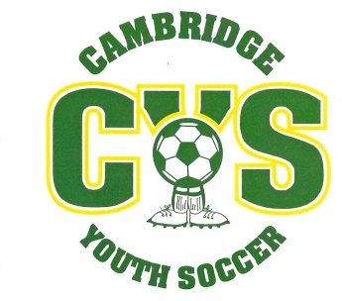
CAMBRIDGE YOUTH SOCCER

How are the registration fees spent?

- Did you know in 2011 CYS spent almost $6000 in providing youth soccer services to the residents of Cambridge & Jeffersonville?

- The $$ is used for the following expenses:
T-shirts & uniforms
League registration fees
Referee fees
Supplies & equipment (field paint, goals etc.)
Website costs

- Did you know that over the past 4-5 years, CYS has purchased brand-new aluminum goals for all fields? These replaced the antiquated metal goals we were using. Each set of goals costs approximately $2000, and there are five sets being used at the present time. Not only is the life-expectancy greater with the aluminum goals, they are considerably safer than the ones they replaced.

